Protechsoft day 5 notes

1. Object
An object is a collection of key-value pairs used to store related data.

Object Literal

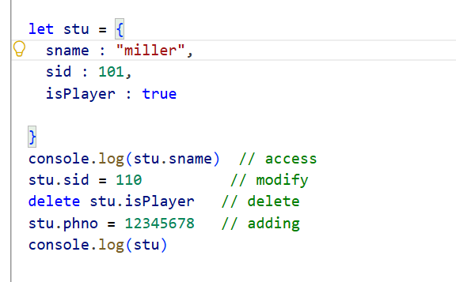Access Property
console.log(stu.sname);

Modify Property
stu.sid = 110;

Delete Property
delete stu.isPlayer;

Add Property
stu.phno = 12345678;

Questions
Q1. What is an object?
Ans: An object is a collection of key-value pairs.
Q2. How do you access object properties?
Ans:
obj.propertyName

2. Object.keys()
Returns all keys of an object in an array.

Example
console.log(Object.keys(stu));
Output
['sname','sid','phno']

3. Object.values()
Returns all values of an object.

Example
console.log(Object.values(stu));
Output
['miller',110,12345678]

4. Object.freeze()
Prevents modification, addition, and deletion of properties.

Example
Object.freeze(ob1);

Rules
Operation | Allowed
Add Property | ❌
Delete Property | ❌
Modify Property | ❌

Question
Q. What is Object.freeze()?
Ans: It makes an object completely immutable.

5. Object.seal()
Allows modification but prevents adding and deleting properties.

Example
Object.seal(ob2);

Rules
Operation | Allowed
Add Property | ❌
Delete Property | ❌
Modify Property | ✅

Question
Q. Difference between freeze and seal?
freeze() | seal()
Modification ❌ | Modification ✅
Add ❌ | Add ❌
Delete ❌ | Delete ❌

6. Object Creation Using Class
Class is a blueprint for creating objects.

Example

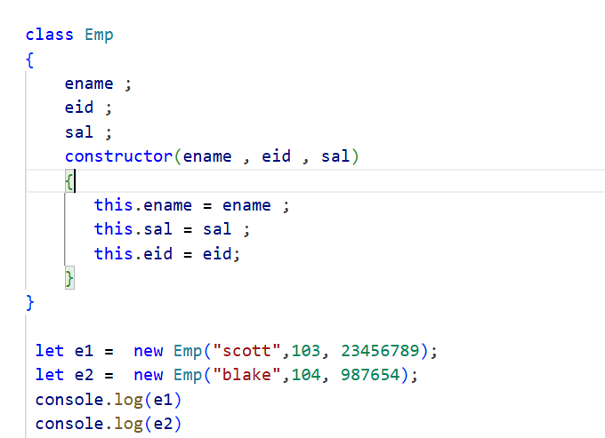

Question

Q. What is a class?
Ans: A blueprint used to create objects.

7. Higher Order Function (HOF)

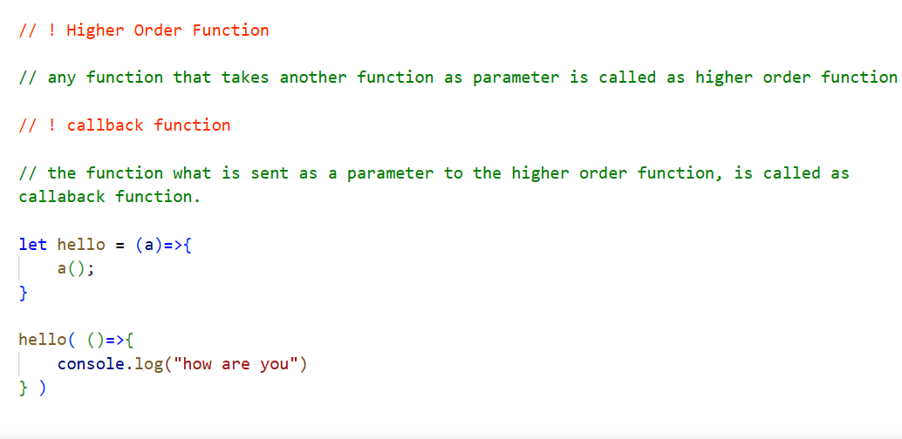
A function that accepts another function as a parameter.

Example
let hello = (a)=>{
a();
}

8. Callback Function
A function passed as an argument to another function.

Example
hello(()=>{
console.log("How are you");
});

9. map()
Used to traverse an array and returns a new array.

Example
let arr = [10,20,30];

let result = arr.map((ele)=>{
return ele + 20;
});
// Output
// [30,40,50]

Features
- Returns new array
- Modifies all elements
- Does not affect original array

Question
Q. What is map()?
Ans: It is used to transform array elements and returns a new array.

10. filter()
Used to filter elements based on a condition.

Example
let marks = [54,34,62,78];

let greater = marks.filter((ele)=>{
return ele > 50;
});
// Output
// [54,62,78]

11. sort()
Used to sort array elements.

Ascending Order
let arr = [9,2,8,5,1];

arr.sort((a,b)=>{
return a-b;
});
// Output
// [1,2,5,8,9]

Descending Order
arr.sort((a,b)=>{
return b-a;
});
Output
[9,8,5,2,1]

12. Rest Parameter (...)
Used to collect multiple arguments into a single array.

Example
let usersAge = (a,b,...c)=>{

console.log(a)
console.log(b)
console.log(c)
}

usersAge(30,32,35,45,41,46,60)
// Output
// 30
// 32
// [35,45,50]

13. Object Destructuring
Extracting object properties into variables.

Example
let bike = {
bikename : "RE",
price : 234567,
color:"white"
}

let {color,bikename , price} = bike ;

console.log(color) // white
console.log(bikename) // RE

14. Spread Operator (...)
It expands elements of arrays or objects.
Used to copy or merge arrays and objects.

Example

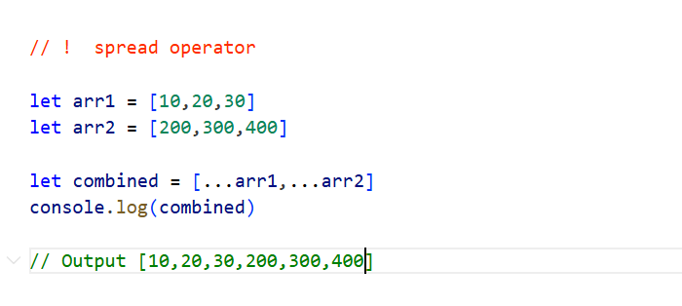

15. Shallow Copy and Deep Copy

Shallow Copy
Original and copied variables share the same reference.
let arr = [10,20];

let copy = arr;
Changes affect both arrays.

Deep Copy
Creates a separate copy.
let arr = [10,20];

let copy = [...arr];
Changes affect only copied array.

Question
Q. Difference between shallow copy and deep copy?
Shallow Copy | Deep Copy
Same Reference | Separate Reference
Changes affect both | Changes affect copied object only

16. API (Application Programming Interface)
A medium through which applications communicate and exchange data.
API allows communication between applications.

Fetch API Example

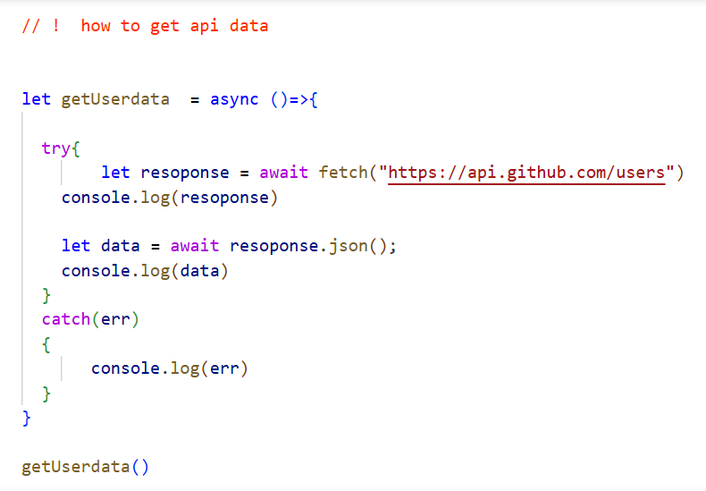

17. Async and Await
An async function always returns a Promise.

await is used inside an async function to pause execution until a Promise is resolved.

18. Promise
A Promise is an object representing the eventual completion or failure of an asynchronous task.

States of Promise
- Pending
- Fulfilled
- Rejected

Example
let p = new Promise((resolve,reject)=>{

resolve("Success");

});

Consuming Promise
p.then((data)=>{
console.log(data);
})
.catch((err)=>{
console.log(err);
});

Questions
Q. What is a Promise?
Ans:
Q. What are the states of Promise?
Ans:
- Pending
- Fulfilled
- Rejected

